

**What are wetlands, and why do we need to protect them?**

**Parthkumar Makwana**

**DAIICT19004 / 202219004 / IIRS19004**

**18/01/2023**

**M.Sc. Agriculture Analytics**

**Programming for Geodata Processing**

* **Abstract:**

Wetland Is Diverse Ecosystem Which Occurs Between Terrestrial And Aquatic Environments. Wetlands Vary From Shallow Water To Emerging Swamps. It Also Includes Small Water Weeds To Big Water Trees, Small Water To Hippopotami, And The Marsh Or Bog Is Home To Plants And Animals. Man Uses Wetlands For Water, Grains And Fish. Wetland Also Helps In Flood Control, Coastal Protection, And Water Purification And Acts As A Carbon Regulators. After All These Advantages, Humans Have Destroyed Or Transformed More Than Half Of The World's Wetlands. Some Still Exist, But Changing Conditions, Global Warming, Living Species, Nutrient Extraction, Pollution And Climate Change Threaten Many. Conservation Activities Focus On Protecting Wetlands, Especially Maintaining The Essential Ecological Processes On Which Wetlands Depend.

This Data Analysis Aims To Identify Wetland Conservation And Its Impact On Indian Ecology.

Q- What Are Wetlands, And Why Do We Need To Protect Them?

(Ref- <Https://India.Mongabay.Com/2021/01/Explainer-What-Are-Wetlands-And-Why-Do-We-Need-To-Protect-Them/>)

The Datasets I Have Collected To Support My Hypothesis Are Taken From Indiastat, Data.Gov.In And Vedas.Sac.Gov.In, National Wetland Atlas. These Are The Four Different Sources That Strengthen The Result Of The Analysis Of Collected Data.

I Have Used Different Methods And Libraries From Python To Analyse And Furnish The Data To The Present. Libraries Which I Have Used Are Numpy, Pandas And Matplotlib.

Using Provided Data And Data Analysis, It Is Derived That Wetlands Are An Integral Part Of Indian Ecology And The Protection And Conservation Of Wetlands Have To Be In Priority.

* **Introduction:**

**What Is A Wetland:-** Wetland Is An Area Where The Soil Is Covered With Water Throughout The Year Or A Specific Period Of Time.

Wetlands Are The Source Or The Primary Ecology For Some Animals, Birds And Plants. Wetlands Are Found All Over India, From Hot Weather In Rajasthan To Cold Weather In The Himalayas And From The Northeast To The Deccan Plateau Of India. Wetlands Produce Highly Fertile And Arable Soil For Agriculture And Are The Best Living Places For The Human Population. Wetlands Not Only Provide Fundamental Human Needs But Also Give Economically Valuable And Highly Valuable Materials.

According To Sciencedirect, 61.2% Of Fishing Was Contributed By Inland Fishing In 2010-11, Much Higher Than 52.3% In 2001-02. Thus. Wetlands Are Irreplaceable Resources For Humankind.

(Ref-<https://www.sciencedirect.com/science/article/pii/s221458181400010X#Bib0280>)

**What Is a Ramsar Site:** The wetlands designated by the criteria of the Ramsar convention, which has International Importance, are called Ramsar sites.

(Ref- <https://jncc.gov.uk/our-work/ramsar-convention/>)

**What Is A Ramsar Convention: -** It Is An International Treaty That Provides Guidelines For Conserving Wetland And Their Resources.

This Convention Was Decided In The Ramsar City Of Iran In 1971. Since then, Almost 172 Countries Have Become Contracting Parties, Having 2471 Designated Sites Having 256,192,256 Ha Area And Committed To [The Convention’s Three Pillars](https://www.ramsar.org/about/the-convention-on-wetlands-and-its-mission):

1. Work Towards The Wise Use Of All Their Wetlands
2. Designate Suitable Wetlands For The List Of Wetlands International Importance And Ensure Their Effective Management
3. Cooperate Internationally On Transboundary Wetlands, Shared Wetland Systems And Shared Species

(Ref - <https://www.wetlands.org/wetlands/ramsar-convention/>)

**Task A:-**

Detect, which I have extracted, has four types of data.

1. Category-wise wetland area of 2011-12 and 2017-18

* In this dataset, data are divided into four categories: natural inland wetlands, natural coastal wetlands, artificial inland wetlands, and artificial coastal wetlands, so I have made two pie charts to analyse the data.

1. State-wise fund release for wetland conservation data

* I have found a total of 3 datasets from different websites., They are complementary, so I have combined the data to fill up nan data and plotted a line chart for this type of time series data.

1. State-wise wetland area data

* Here I have extracted data from two different websites. The data has state-wise wetland areas in 1994, 2005 and 2016. So I have plotted data on multiple bar graphs to analyse.

1. Fishing data in wetland

* Here I have the data on the percentage of fishing between inland wetlands and coastal or marine wetlands. So I have plotted these two variable data on multiple bar graphs to analyse.
* **Datasets Links**:-

1. <https://www.indiastat.com/table/scheme-for-welfare-of-wildlife/selected-state-wise-fund-released-under-conservati/63420>
2. <https://www.indiastat.com/table/environment-and-forest/state-wise-funds-released-under-national-wetlands-/423321>
3. <https://www.indiastat.com/table/environment-and-forest/selected-state-wise-funds-released-conservation-we/1424141>
4. <https://www.indiastat.com/table/miscelleneous-geographical-facts/category-wise-number-area-wetlands-india-2017-2018/1428226>
5. <https://www.indiastat.com/table/environment-and-forest/-selected-state-wise-funds-released-central-assist/1183283>
6. <https://www.indiastat.com/table/environment-and-forest/selected-state-wise-funds-released-ministry-enviro/645842>
7. <https://www.sciencedirect.com/science/article/pii/s221458181400010X#Bib0280>
8. <https://data.gov.in/resource/state-wise-wetland-distribution-india-reply-unstarred-question-25-07-2016-ministry>
9. <https://data.gov.in/resource/stateuts-wise-funds-released-under-conservation-wetlands-2017-18-2021-22>
10. <https://vedas.sac.gov.in/vedas/downloads/atlas/Wetlands/National%20Wetland%20Atlas_Ramsar%20sites%20of%20India.pdf>
11. <https://indianwetlands.in/wetlands-overview/national-wetlands-statistics/>

**Research Question:-**

**What are wetlands, and Why do we need to protect them?**

(Ref- <Https://India.Mongabay.Com/2021/01/Explainer-What-Are-Wetlands-And-Why-Do-We-Need-To-Protect-Them/>)

This article describes what wetland is, the importance of wetlands, the dependency of humans on wetlands, the advantages of wetlands, recent threats to natural wetlands, and why and how to conserve wetlands.

If forests are the filter of air, then wetlands are water filters, and wetlands are the filters of landscape waste. A total of 4.63% geographical area of India is wetland, and 7,57,060 wetland sites have been identified till Nov. 2022

(<https://www.iucn.org/sites/dev/files/content/documents/wetland_day_news_south_asia.pdf>)

Importance:- Wetlands Includes Small Water Weeds, Too Big Water Trees, and Small Water To Hippopotami, And The Marsh Or Bog Is Home To Plants And Animals. Man Uses Wetlands For Water, Grains And Fish. Wetland Also Helps In Flood Control, Coastal Protection, And Water Purification And Acts As A Carbon Regulators.

Threat:- From the early 1700 world started losing its natural wetlands. India Lost its 1/3 wetlands at the cost of urbanisation, agriculture and development. Wetlands are in danger due to drainage, savage, polluted untreated water mix. Due to all this systematical pollution ecology of wetlands is disrupted.

**Task B:-**

1. I have plotted a pie chart for categorical data of Indian wetlands based on natural inland wetlands, natural coastal wetlands, artificial inland wetlands and artificial coastal wetlands. And plotted another multiple-bar graph of fishing in inland marshes and coastal or marine swamps from 2001-02 to 2010-11. Then I compared the change in any data category with the percentage share in fisheries.

Ex.- Effect of Change in a natural inland wetland on percentage share in fisheries.

1. Other two charts which I have prepared. One of them is a line series chart which consists state wise time series data on funds released by the state government for wetland conservation. And other one consists of state-wise data on the area covered by wetlands in 1994, 2005 and 2016.

Using these data, I have analysed the relation between the increment or decrement of funds for wetland conservation with changes in the wetland area.

* **Analysis:**

**Task C:-**

1. **Category-wise wetland Analysis**

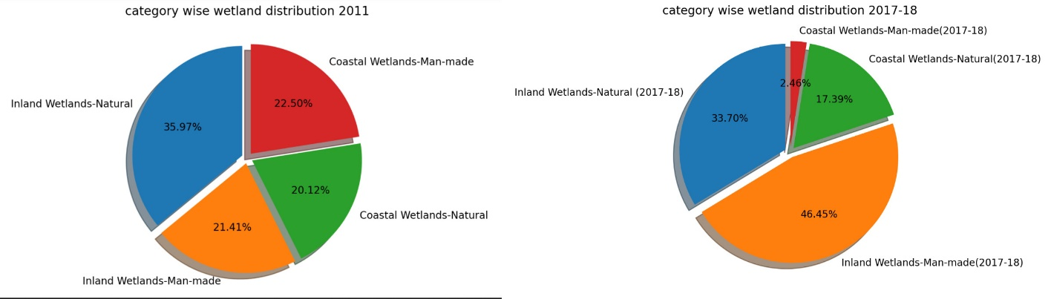

* Here, we can see that the percentage category-wise wetland distribution changed from 2011 to 2017.
* Percentage of inland wetlands, either natural or artificial, had increased. Inland wetland man-mad has risen sharply from 21.41% to 46.45%, and for coastal wetlands, artificial had sharply decreased from 33.50% to 2.46%, showing that interest in fish farming has changed from coastal to inland wetlands.
* As per percentage data, natural coastal wetlands also decreased, and inland wetlands natural is increased

1. **Categorical data on fishing**

* 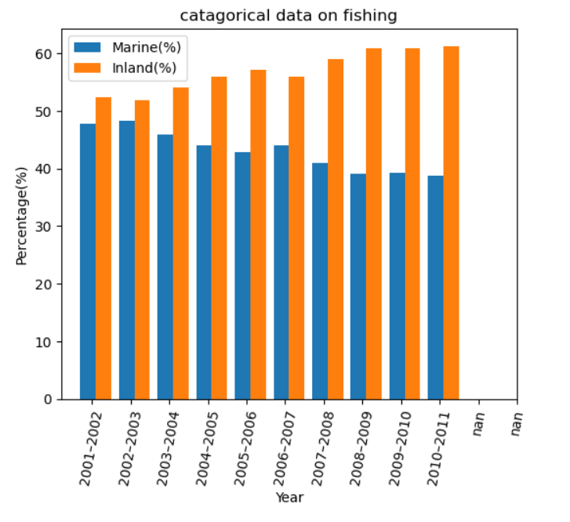As per the chart, we can say that the percentage contribution of marine and inland fish production has changed similarly.
* Marine fishing contribution has decreased in the same manner, and inland fishing if increased in the same way.
* As per analyses 1 and 2, we can say that fishing data fluctuates due to changes and decreases in marine or coastal wetland areas.

1. **Fund release for wetland conservation:-**

* Here, we have given a line chart of selective statewide fund allocation to conserving wetland areas below.
* As shown below, the image fund allocation for Gujarat, Himachal Pradesh, Jammu and Kashmir, Manipur and Orissa is given.
* In early 2000, Funds for wetland conservation were meagre, but after 2006-7 trend has been changed, and fund allocation to the states for wetland conservation increased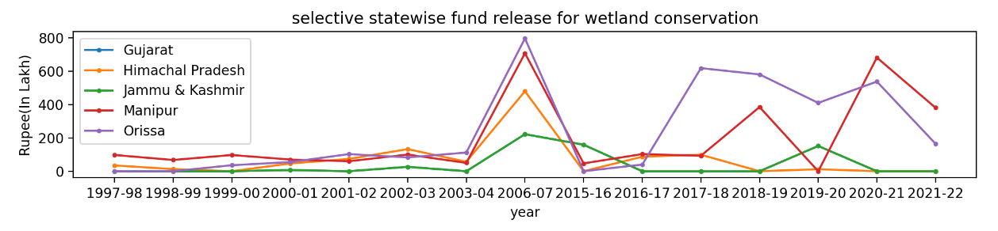 So we can say that in future, due to increment in fund allocation for wetland conservation, wetland areas can be increased
* As per the graph, Orissa is allocating the highest amount of money for wetland conservation

1. **Statewise change in the wetland area**

* Here, we have given a multiple bar graph of state-wise change in wetland areas for the years 1994,2005 and 2016.
* Here we can see that the wetland area slightly increased or was equal between 1994 and 2005. But after 2005 the wetland area rises highly.
* Hence proved that As per graph no three, we have said that after 2006-07 the wetland area will increase due to increment in funds for wetland conservation.

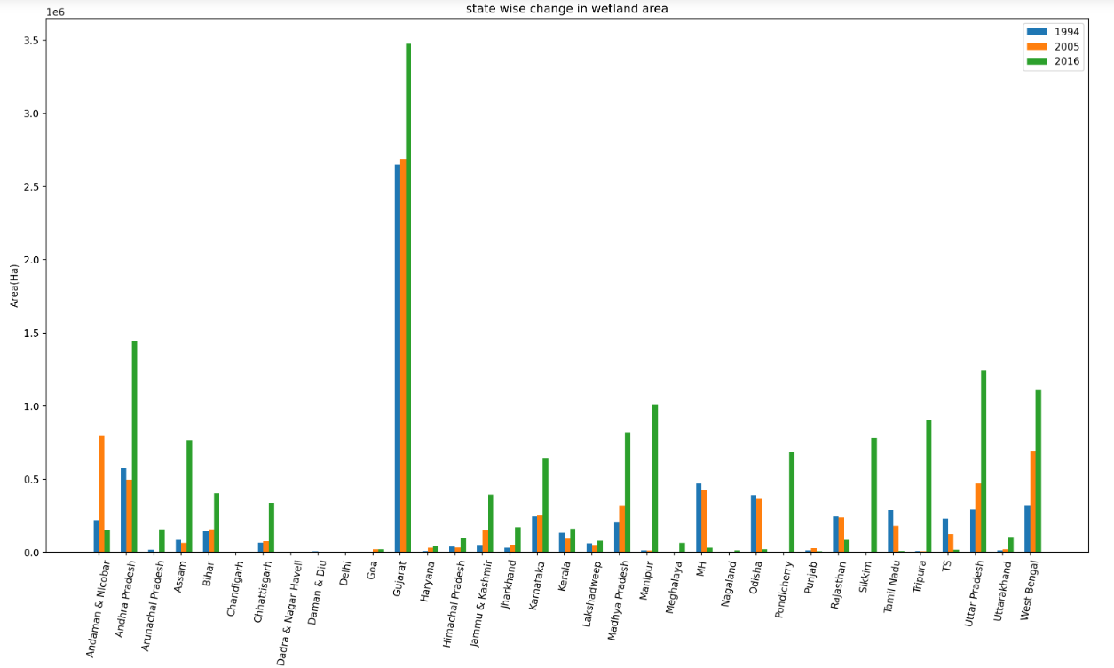

* Here, Manipur shows the biggest change in the hector area and the most significant change in the percentage area.
* **Conclusion:-**

Different sectors like fisheries, irrigation, agriculture, tourism, and water resources cover wetlands. For example, all water bodies in the country are under the direct management of the Water Resource Department.

Urban development, overexploitation of water, overuse of chemicals and climate change are significant problems for wetland conservation. Efforts to conserve the wetlands are outstanding, but more is needed to preserve the environment for the living organism their needs. Wetland ecosystems are interconnected with each other. In India, unplanned urbanisation and population growth are harming wetlands. To counter this, wetland management has to work with planning, implementation and monitoring. Effective links between trained academics and professionals, including ecologists, hydrologists, economists, watershed management specialists, planners and policymakers, will contribute local expertise and expertise for overall wetland management. It must be combined. All of this will advance our knowledge and understanding of wetlands and develop more comprehensive long-term conservation and management strategies. Constant monitoring of wetland water quality and raising awareness by initiating educational programs on the importance of wetlands in local schools, universities and the general public close to water bodies are essential in protecting wetlands from further degradation. It will be a contribution.

**Task D:-**

Wetland conservation can depend on many factors like urbanisation and global warming, including harmful gas and greenhouse gas emissions.

So many factors can be fundamental factors of any particular wetland.

For example – many water bodies have their natural resources of chemicals. So they always are in a polluted condition.

Also, This data is limited to India-specific regions. So conditions change depending on the geolocation of data.

* **References:-**

1. <https://india.mongabay.com/2021/09/commentary-india-establishes-the-largest-network-of-ramsar-sites-in-south-asia/>
2. <https://india.mongabay.com/2021/06/commentary-india-holds-great-promise-in-this-decade-on-ecosystem-restoration/>
3. <https://www.indiawaterportal.org/articles/indian-wetlands-under-threat>
4. <https://timesofindia.indiatimes.com/city/raipur/wetlands-to-be-developed-for-groundwater-recharge/articleshow/93335637.cms>
5. <https://newsonair.com/2022/11/14/cop14-environment-and-wetlands-conservation-an-integral-part-indias-cultural-ethos/>
6. <https://timesofindia.indiatimes.com/city/nagpur/conservation-of-wetlands-will-help-recover-lost-bird-species/articleshow/96995035.cms>
7. <https://www.sciencedirect.com/science/article/pii/S221458181400010X>
8. <https://dec.vermont.gov/watershed/wetlands/functions/water-quality>
9. <https://www.downtoearth.org.in/blog/environment/the-state-of-india-s-urban-wetlands-and-why-they-need-to-be-protected-urgently-78456>
10. <https://jncc.gov.uk/our-work/ramsar-convention/>
11. <https://vikaspedia.in/energy/environment/know-your-environment/conservation-of-wetlands#:~:text=The%20loss%20of%20wetlands%20leads,in%20water%20quality%20could%20result>.